VEX IQ Level Up: Session 5
Activity: Test and choose an improvement for Flop!
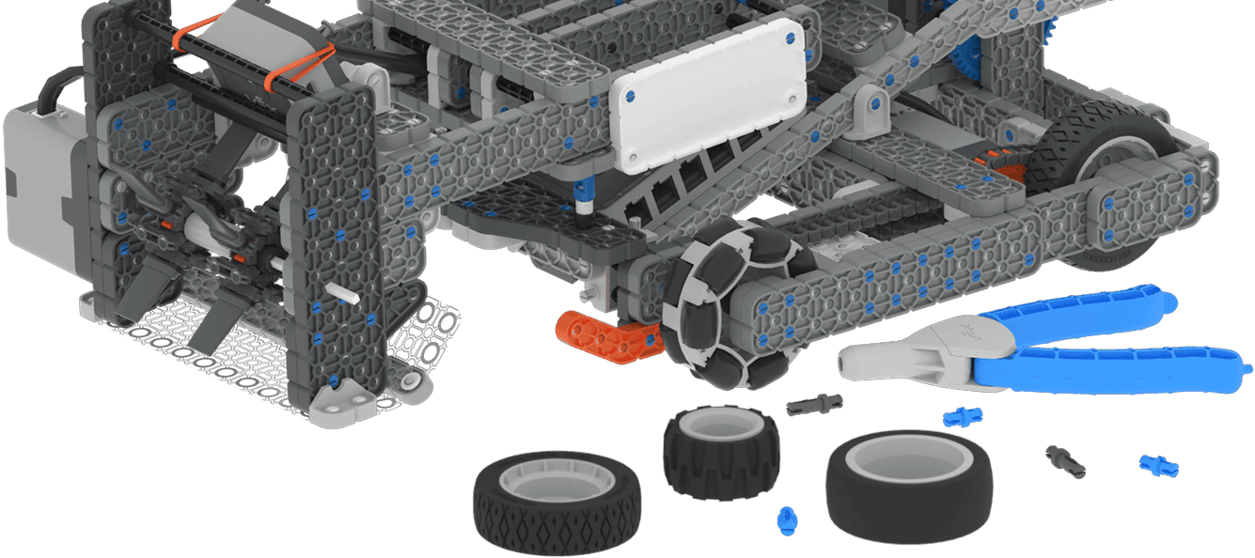
- Think about one wheel improvement your team could make. Sketch or record your idea in your engineering notebook. Consider:
  - What wheels you have to choose from
  - Which wheels to change
- Document your current robot. Use pictures and sketches to ensure you can undo any changes.
- Choose one plan for changing the wheels with your team.
  - Decide as a team which wheel modification you will try first.
  - Everyone on the team should agree to the plan.
  - Decide who will make the adjustments to the robot, who will drive the robot during testing, and who will collect data on the test.
- Make and test the wheel change. Use the driving test you completed previously and collect data in your engineering notebook.
- Repeat steps 3 and 4 to collect data about multiple wheel improvements.
- After testing multiple wheels, come together to discuss the results of your testing. Use your data to decide on which wheel improvement to keep.
Example Documentation:
Modification | Wheels Used | Time | Notes
Change Front Wheels | Omni - Back  Traction - Front | 
Feeling Stuck?
- Make 1 change at a time and collect data. Don’t change more than one variable before testing!

Discussion Questions  - How did the wheel change affect the robot’s performance?  - How does this wheel improvement relate to your strategy from Session 4?  - What ideas do you have for another way to test wheel changes? | Activity Checklist  - The team chose a plan for improving the wheels.  - Data was collected from testing multiple wheel changes.  - The team chose a final wheel change to keep.

